LAB EXPERIMENT RECORD

Set 8: Employee Performance Analysis

Department | AIML
Course Code / Course Name | DSA0602 / Data Handling and Visualization
Experiment | Data Visualization using R and Tableau
Name | S.Naveen Kumar
Register Number | 192425176
Date | 3 October 2026
Day | Saturday

Aim
To analyze employee performance by visualizing the performance trend using a line chart, the distribution of employees across departments using a bar chart, presenting the performance data in a labelled table, and combining these views in an interactive Tableau dashboard.

Dataset: Employee Performance

Employee ID | Department | Years of Service | Performance Score
1 | Sales | 5 | 85
2 | HR | 3 | 92
3 | Marketing | 7 | 78

PROGRAM 1: Line Chart of Employee Performance Trend
Create a line chart to visualize the performance trend of employees over time. Label the axes and title the chart.
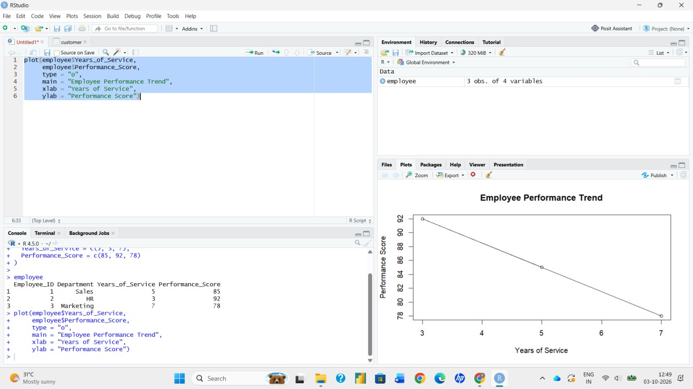
# Dataset
employee <- data.frame( Employee_ID = c(1, 2, 3),
Department = c("Sales", "HR", "Marketing"), Years_of_Service = c(5, 3, 7),
Performance_Score = c(85, 92, 78)
)

# Order by years of service (time axis)
ordered <- employee[order(employee$Years_of_Service), ]

# Line Chart
plot(ordered$Years_of_Service, ordered$Performance_Score, type = "o",
pch = 19, xaxt = "n",
xlab = "Years of Service", ylab = "Performance Score",
main = "Employee Performance Trend by Years of Service", col = "blue")
axis(1, at = ordered$Years_of_Service)

Output 1: Employee Performance Line Chart

Observation: Since the dataset has no date column, Years of Service is used as the time axis. Performance falls from 92 at 3 years to 85 at 5 years and 78 at 7 years, showing a steady downward trend. With only three employees, this pattern is indicative and not conclusive.

PROGRAM 2: Bar Chart of Employees by Department
Generate a bar chart showing the distribution of employees across different departments. Label the chart elements.
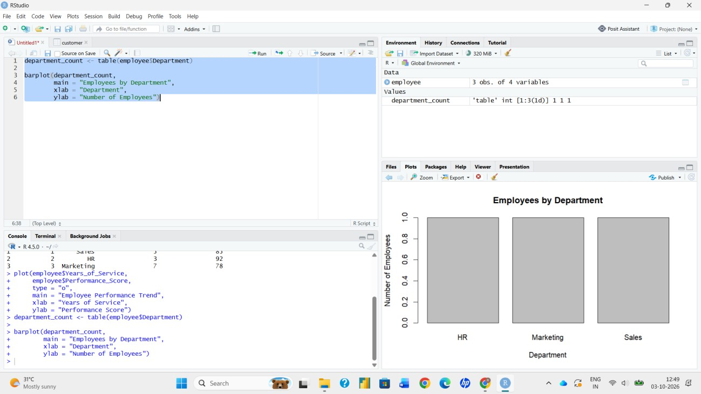
# Count employees in each department dept_count <- table(employee$Department)

# Bar Chart barplot(dept_count,
xlab = "Department",
ylab = "Number of Employees",
main = "Distribution of Employees by Department",
col = c("darkseagreen", "sandybrown", "cornflowerblue"), ylim = c(0, 2))

Output 2: Employees by Department Bar Chart
Observation: Each of the three departments (HR, Marketing and Sales) has exactly one employee, so employees are evenly distributed across the departments in this dataset.

PROGRAM 3: Table of Employee Performance Data
Build a table to display the performance data for each employee. Label the table elements.

# Build and label the table performance <- employee
colnames(performance) <- c("Employee ID", "Department", "Years of Service", "Performance Score")

print(performance)

 | Em  1 | ployee  1 | ID Departmen  Sales | t Yea  5 | rs of | Service Performance Score  85
 | 2 | 2 | HR | 3 |  | 92
 | 3 | 3 | Marketing |  | 7 |  | 78
Output 3(a): R Console Output
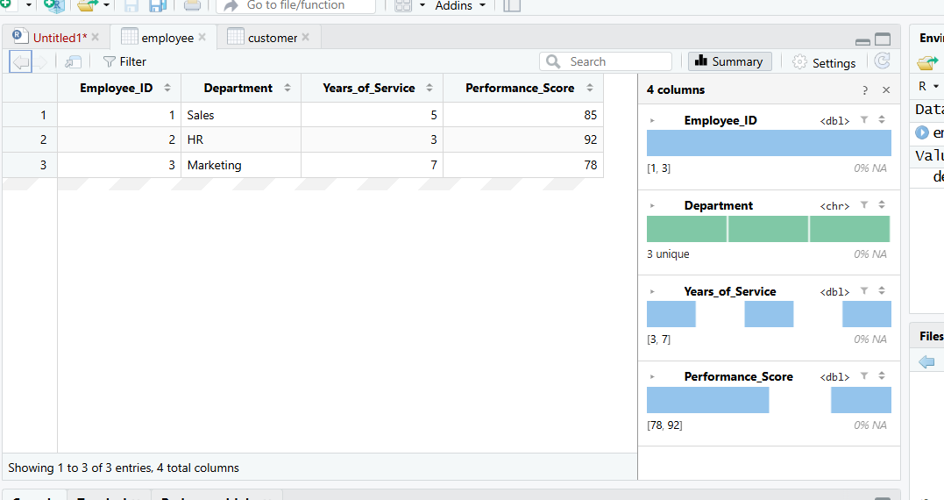
Output 3(b): Employee Performance Data Table
Observation: The HR employee has the highest score (92) with the shortest service of 3 years, while the Marketing employee has the lowest score (78) with the longest service of 7 years. The average performance score is 85.

PROGRAM 4: Interactive Tableau Dashboard
Develop a Tableau dashboard combining the line chart, bar chart, and the table for interactive exploration of employee performance data.
- Open Tableau, choose Connect > Text file (or Microsoft Excel) and select the employee performance file.
- Open Sheet 1 and create the line chart: drag Years of Service (as a Dimension, continuous) to Columns and Performance Score to Rows, and set the Marks type to Line. Add circle markers and labels, and rename the sheet to “Performance Trend”.
- Open Sheet 2 and create the bar chart: drag Department to Columns and Employee ID (Count Distinct) to Rows. Rename the sheet to “Employees by Department”.
- Open Sheet 3 and create the table: add Employee ID, Department, Years of Service and Performance Score to Rows to show the text table. Rename the sheet to “Performance Data”.
- Click New Dashboard, drag the three sheets onto the canvas and arrange them as shown in the output.
- Add a Department filter (right-click Department > Show Filter) and apply it to all worksheets using this data source.
- Select the bar chart and click “Use as Filter” so that selecting a department updates the line chart and the table.
- Add a dashboard title and test the interactivity by selecting different departments.
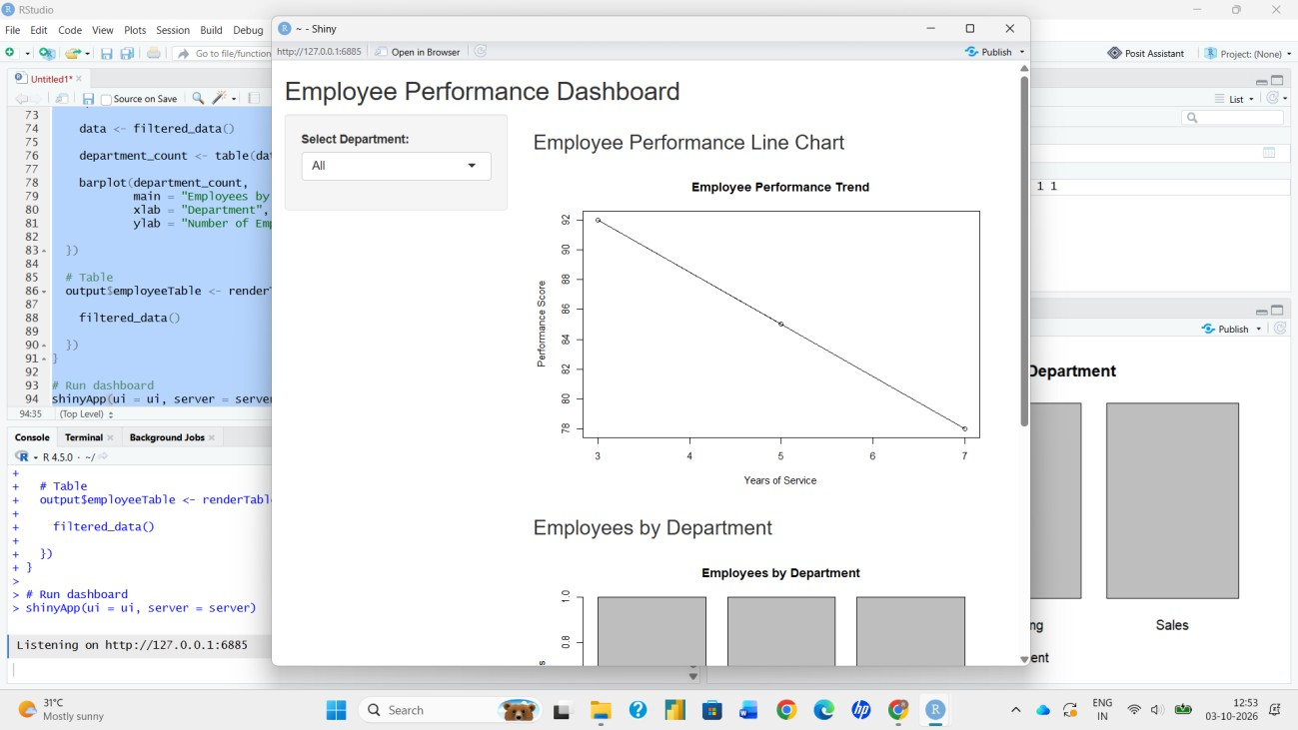
Output 4: Employee Performance Tableau Dashboard

Observation: The dashboard presents the performance trend, department distribution and employee records in one view. The Department filter and the Use as Filter action update every sheet together for interactive exploration.

Procedure
- Create the employee performance data frame in R.
- Sort the data by Years of Service and use plot() with type = "o" to draw the performance line chart.
- Use table() and barplot() to show the number of employees in each department.
- Rename the columns with colnames() and print the labelled performance table.
- Load the data into Tableau and build the line chart, bar chart and table on separate worksheets.
- Combine the worksheets on a dashboard and add the Department filter and the Use as Filter action.

Result
The employee performance data was successfully visualized using a line chart of the performance trend, a bar chart of the department distribution and a labelled performance table in R. An interactive Tableau dashboard combining all three views was also created.

Key Functions / Tools Used

Function / Tool | Purpose
data.frame() | Creates the employee dataset.
order() | Sorts employees by years of service.
plot() / axis() | Creates the line chart and custom axis ticks.
table() | Counts employees in each department.
barplot() | Creates the department distribution bar chart.
colnames() / print() | Labels and displays the performance table.
Tableau Dashboard | Combines the worksheets into one interactive view.

